Thank you for helping to spread the word about Cystinuria Awareness Day,
which takes place on Saturday, June 24, 2023!

Together, we can raise awareness of Cystinuria through a coordinated SOCIAL MEDIA CAMPAIGN during the week of June 19-24.

5 EASY WAYS TO PARTICIPATE:

Frequently share social media content and graphics during the week of June 20 and tag your state legislators every time you post. To make it easy, you can simply copy and paste or download from the content samples provided below. If you or someone in your life has been personally impacted by Cystinuria, please consider customizing these samples and/or creating your own social media content. It’s important for policymakers, healthcare providers, the media, and the public to hear about the personal experiences of people living with Cystinuria. Tag your state legislators and legislatures in your posts - you can find information on their social media sites here.
1

Some Creative Ways to Customize Your Content to Engage Your Social Media Audience:
- Share a short video or a personal photo that shares and shows something about YOUR Cystinuria experience
  - Example: show a container that holds the amount of water you drink in a day and tell why. “I drink this much water every day. Why? Because it helps to manage a rare, genetic kidney disorder I have called Cystinuria. I’m sharing this with you because today is Cystinuria Awareness Day. You can learn more at cystinuria.org”.

  - Example: share a video or photo showing your kidney stones. “I’m a real-life rock star, and I have the stones to prove it! I have a rare kidney condition called Cystinuria that causes the formation of frequent and recurrent kidney stones like these. Cystinuria Awareness Day is this week, and I hope you’ll visit cystinuria.org to learn more!

Change your Facebook and LinkedIn cover photos to the design provided with instructions below.
2
3
Use a Cystinuria Awareness virtual meeting (Zoom) background. The background design options and instructions on how to use are provided below.

Share this social media toolkit document with your family, caregivers, friends, coworkers, healthcare providers, and others – and ask them to also participate through these five easy ways!
4
Share your story and/or the reasons why you care about Cystinuria Awareness Day with your lawmakers. You can find contact information for your federal and state lawmakers by simply entering your zip code here.
5

HOW TO SHARE ON SOCIAL MEDIA
Please share the awareness day information on ALL your organizational and individual social media accounts, including Twitter, Facebook, Instagram, and LinkedIn. Please use the hashtags #CystinuriaDay2023 #rarekidneystones and #rarediseaseawareness every time you share. You can post the content and graphics separately or combine them however you wish.

DIGITAL ASSET LINK:

Note: because we want to raise awareness of Cystinuria among policymakers, we encourage you to tag your state legislators and legislatures in your posts. You can find information on their social media sites here.

SAMPLE SOCIAL MEDIA CONTENT
Can be combined with graphic options below or used alone

TWITTER:

Cystinuria Awareness Day is June 24! #Cystinuria is a rare, serious genetic disorder characterized by frequent and recurrent #kidney stone formation. Learn more at cystinuria.org! #CystinuriaDay2023 #rarekidneystones #rarediseaseawareness

1 in 10,000 Americans has #Cystinuria, a #raredisease causing frequent and recurrent #kidney stone formation. June 24 is Cystinuria Awareness Day. Learn more at cystinuria.org. #CystinuriaDay2023 #rarekidneystones #rarediseaseawareness

Learn more about #Cystinuria, a #raredisease that can lead to chronic #kidneydisease if not properly managed. June 24 is Cystinuria Awareness Day! Visit cystinuria.org. #CystinuriaDay2023 #rarekidneystones and #rarediseaseawareness

FACEBOOK / LinkedIn:

June 24 is Cystinuria Awareness Day. Cystinuria is a rare, serious genetic disorder characterized by frequent and recurrent kidney stone formation. It affects both men and women and is a lifelong, chronic condition. While cystinuria has no cure, it can be managed. Early diagnosis is important. Learn more at cystinuria.org.

#CystinuriaDay2023 #rarekidneystones and #rarediseaseawareness

Cystinuria is a rare disease that causes frequent and recurrent kidney stone formation. It affects about 1 in 10,000 people in the US. Cystinuria Awareness Day is observed on June 24 – learn more at cystinuria.org.

#CystinuriaDay2023 #rarekidneystones and #rarediseaseawareness

Cystinuria can lead to chronic kidney disease, which, if not properly managed, can worsen and become kidney failure requiring dialysis or a kidney transplant. Early diagnosis and treatment are important. Cystinuria Awareness Day is June 24 – learn more at cystinuria.org.

#CystinuriaDay2023 #rarekidneystones and #rarediseaseawareness

June 24 is Cystinuria Awareness Day. Treatment for patients with cystinuria often focuses on drinking more fluids and reducing foods that are high in sodium and in animal protein. Medications can also help reduce the formation of cystine stones in the kidneys. Learn more at cystinuria.org.

#CystinuriaDay2023 #rarekidneystones and #rarediseaseawareness

INSTAGRAM:

Cystinuria Awareness Day is held on June 24. Cystinuria is a rare, serious genetic disorder characterized by frequent and recurrent kidney stone formation. It affects both men and women and is a lifelong, chronic condition. While cystinuria has no cure, it can be managed. Early diagnosis and ongoing management are important. Learn more at cystinuria.org. #CystinuriaDay2023 #rarekidneystones #rarediseaseawareness #kidneydisease #kidney

June 24 is Cystinuria Awareness Day. Cystinuria is a rare disease that causes frequent and recurrent kidney stone formation. It affects about 1 in 10,000 people in the US. Learn more at cystinuria.org. #CystinuriaDay2023 #rarekidneystones #rarediseaseawareness #kidneydisease #kidney

June 24 is Cystinuria Awareness Day. Cystinuria can lead to chronic kidney disease, which, if not properly managed, can worsen and become kidney failure requiring dialysis or a kidney transplant. Early diagnosis and treatment are important. Learn more at cystinuria.org. #CystinuriaDay2023 #rarekidneystones and #rarediseaseawareness #kidneydisease #kidney

June 24 is Cystinuria Awareness Day. Treatment for patients with cystinuria often focuses on drinking more fluids and reducing foods that are high in sodium and in animal protein. Medications can also help reduce the formation of cystine stones in the kidneys. Learn more at cystinuria.org. #CystinuriaDay2023 #rarekidneystones #rarediseaseawareness #kidneydisease #kidney

Sample Social Media Graphics
(These can be combined with above content options or used alone)
Uploading Instructions:
Copy and paste the images below or download the preferred image to an accessible folder on a computer or to the photos app on a phone. Go to the website/app of your choosing, and upload the image with any of the caption options above accompanied by the shareable hashtags: #CystinuriaDay2023 #rarekidneystones and #rarediseaseawareness
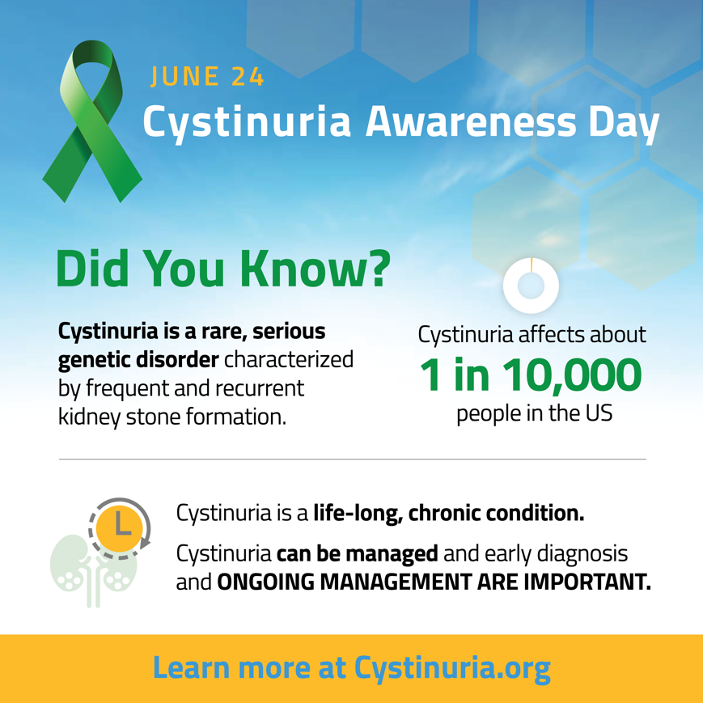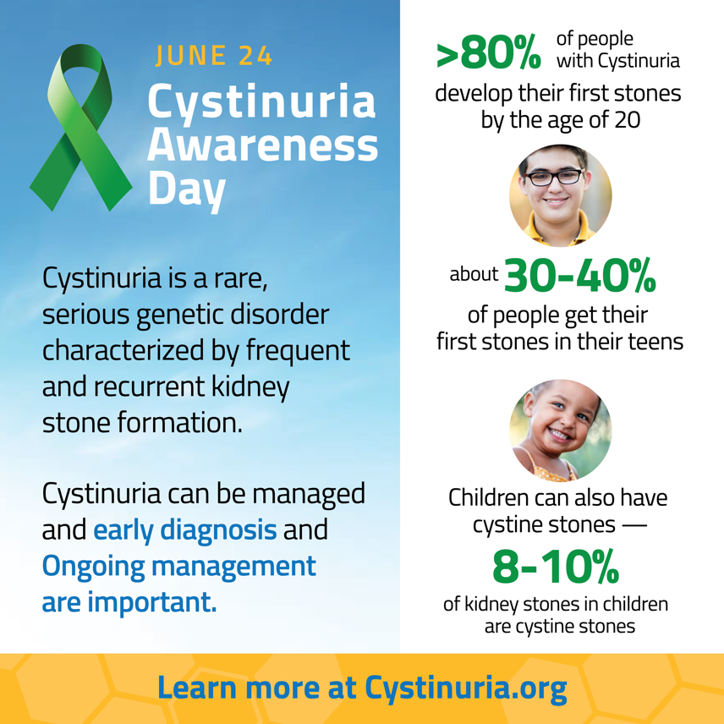

AWARENESS RIBBONS

Sample Social Media Content and Photos

TWITTER/ FACEBOOK/ INSTAGRAM/ LinkedIn:

I drink lots of water every day to help me manage my Cystinuria, a rare, genetic kidney disorder that causes recurrent kidney stones. Learn more at cystinuria.org.

#CystinuriaDay2023 #rarekidneystones #rarediseaseawareness #kidneydisease #kidney

(You can use photo below or one of your own)

I’m a real-life ROCK STAR with the stones to prove it! Frequent and recurrent kidney stones are signs of #Cystinuria, the rare kidney disorder that I live with. Learn more at cystinuria.org.

#rarekidneystones #rarediseaseawareness #kidneydisease #kidney

(You can use photo below or share your own)

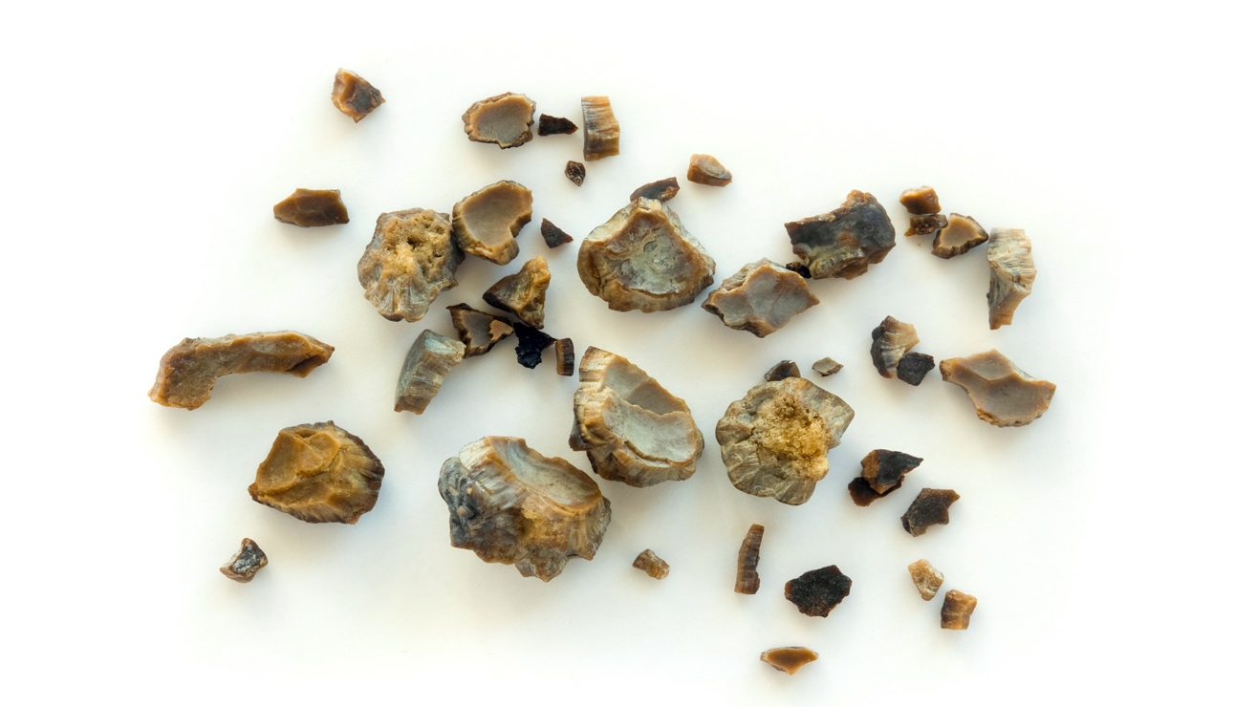

Zoom Backgrounds
Uploading Instructions:
To upload either image below as a Zoom background, start by downloading the images to an accessible folder on your computer. Then open the Zoom application and click on the setting button in the top right corner of the screen directly below your initials. Once you are in settings, select the Background & Filters button from the left-hand side of the screen. You should see a few options for a virtual background. For this banner to appear, click on the ‘plus’ button in the middle of the right-hand side of the screen. From there, you will be able to select either image option to successfully upload the Cystinuria Awareness Day Background image.
Option 1:
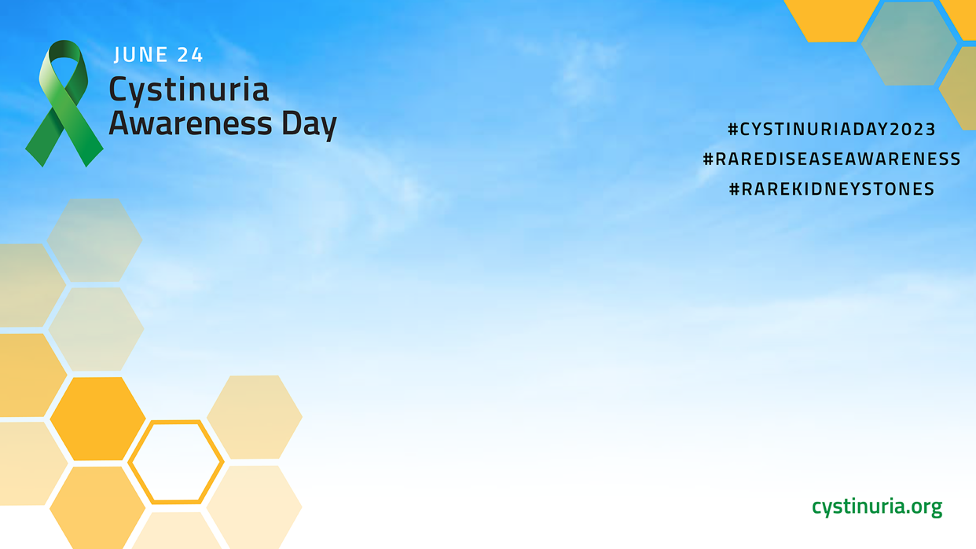
Option 2:

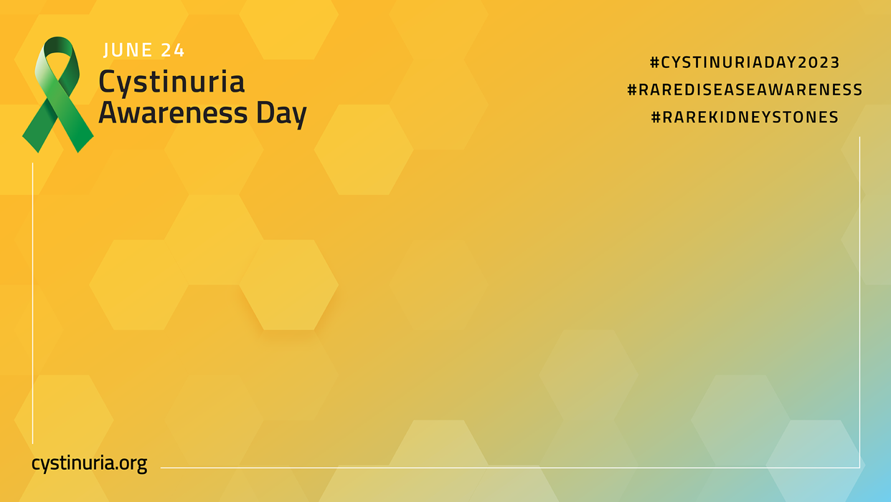

Facebook/LinkedIn Cover Banner Image
Uploading Instructions:
To apply this banner image to a Facebook profile, simply download the image below and save it to an accessible folder on your computer or save it as an image on a phone. Go to the Facebook website/app and find your personal profile page. Once you click on your profile, find the camera icon at the bottom left corner of the cover banner. Select the second option, ‘upload photo’, and find the banner image previously downloaded. Once that image is selected, the banner should be uploaded to your profile representing the Cystinuria Awareness Day image.

